**Requirement Document: Call Center Features**

**DT App Modifications:**

* 1. Add menu option "Call Center" below voicemail in the DT app user interface.

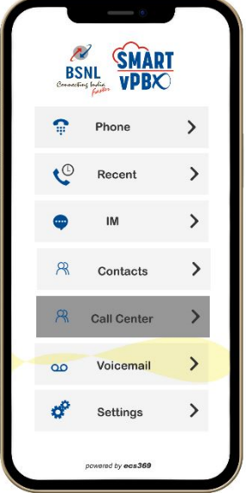

1.2 In the second div of the "Call Center" page, the following buttons will be displayed:

* "Resume Agent" button: Allows agents to resume their call handling activities.
* "Active Agent" button: Indicates the current active agent handling calls.
* "Login Agent" button: Enables agents to log in to the call center system.
* "Logout Agent" button: Allows agents to log out from the call center system.

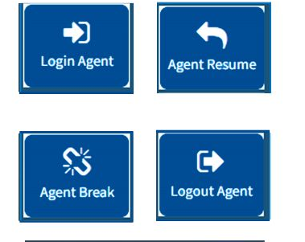

* 1. On clicking the "Login Agent" button, a square box(div) will be displayed in the second div (as shown in image above), specifically in the "Login Ready" box below the four buttons mentioned above. This box indicates that the agent is ready to receive incoming calls.

This div will provide information such as:

Logged In/Logged Out/Ready(etc.) status: Indicates whether the agent is currently logged in, logged out, or ready to receive calls.

Report of Total Calls: Displays the total number of calls received by the agent.

Report of Inactive Calls: Shows the count or details of inactive calls handled by the agent.

Report of Missed Calls: Provides information on the number or details of missed calls by the agent.

These reports will give an overview of the agent's call activities and help in tracking their performance and call handling efficiency.

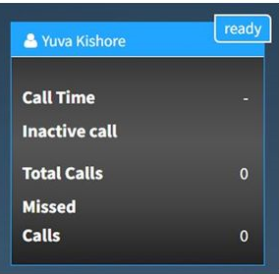

* 1. In the third div of the "Call Center" page, incoming calls will be displayed like how they appear in a phone dialler page.

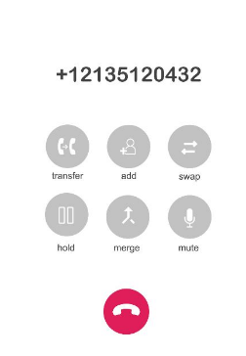

**Monster UI Modifications:**

2.1 Ensure that if one person is attending a call, the system does not allow another person to log out. This functionality should be implemented within the code to prevent inadvertent logouts when someone is already handling a call.

2.2 Add a "Reports" menu in the "Call Center" section, located after the "Manage Queue" feature. This menu will provide options for generating reports related to inactive calls or other relevant call center metrics.

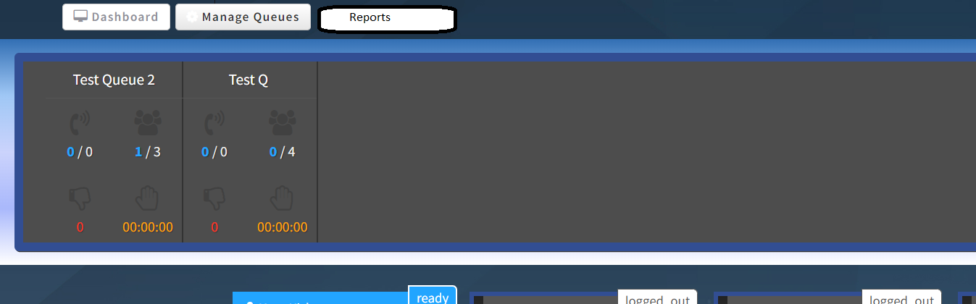

Note: The above requirements provide an overview of the desired modifications to the DT App and Monster UI for the call center